AFFORDABLE HOUSING FINANCE &

OVERVIEW OF CALIFORNIA AFFORDABLE HOUSING FUNDING PROGRAMS

Table of Contents:

I. Introduction to affordable housing finance

II. Historical overview of federal and state investments

III. What is “affordable” housing?

IV. Who is considered low-income in California?

V. Developing affordable housing in California.

How much does it cost to build an affordable unit in California?

What does it take to fund a housing project in California?

VI. What is “social” housing?

How is “social housing” defined in California?

VII. State resources

Current housing agencies in state government

California Department of Housing and Community Development (HCD)

California Housing Finance Agency (CalHFA)

California Tax Credit Allocation Committee (CTCAC)

Debt Limit Allocation Committee (CDLAC)

Strategic Growth Council (SGC)

Interagency Council on Homelessness (Cal-ICH)

Governor’s Reorganization Plan of 2025

Demand far exceeds available state funds

VIII. Federal resources

IX. Local resources

I. Introduction

Developing housing that is affordable to very low- and low-income families almost always requires some amount of public investment. Unlike market-rate housing, tenants in affordable housing are only required to pay 30% of their income toward rent, so the state provides enough long-term subsidy to reduce the overall debt service on a development. The high cost of land and construction, as well as regulatory barriers, in California generally makes it economically impossible to build new housing that can be sold or rented at prices affordable to such households. The private sector sometimes provides financial subsidies or land donations mandatorily through inclusionary zoning policies or voluntarily through density bonus ordinances, described below. In most cases, however, some amount of public financial subsidy is needed from federal, state, and/or local governments.

II. Background: Federal and state investments

Until the 1980’s, public subsidies for affordable housing construction were largely provided at the federal level. In the 1970s and 1980’s, “public housing” – created to provide safe and affordable rental housing for low-income families, the elderly, and people with disabilities under the National Housing Acts of 1934 and 1937 – began to physically deteriorate due to federal disinvestment and prevailing attitudes toward such housing. In 1973, President Nixon issued an 18-month moratorium on federal funding for public housing projects, which worsened conditions within such projects and stymied further construction. A year later, , the Housing Community and Development Act ended most new construction of public housing and the Housing Choice Voucher (HCV) Program (formerly referred to as “Section 8” vouchers) was created in its place. This new program allowed eligible tenants to pay only a portion of their rent (based on their income) and shifted funds from public housing authorities to the private sector. The goal was to eliminate concentrations of low-income people in housing developments.

In 1981, the Reagan administration dismantled federal affordable housing funding. From 1978 to 1983, the funding for low- to moderate-income housing decreased by 78%. Additionally, between 1976 - 1982, the proportion of the eligible low-income families who received federal housing subsidies declined; specifically, Section 8 vouchers dropped 71% (517,000 to 150,000). In 1970, there were 300,000 more low-cost rental units (6.5 million) than low-income renter households (6.2 million). By 1985, however, the number of low-cost units had fallen to 5.6 million, and the number of low-income renter households had grown to 8.9 million, a disparity of 3.3 million units. If subsidized housing construction maintained their 1973 levels, there would have been 5.7 million more units nationwide in 2020.

Later in 1998, President Clinton signed the Faircloth Amendment, prohibiting federal funds from going to any new public housing projects that would result in a net increase of public housing units above 1999 levels. To this day, Faircloth remains intact, kneecapping any meaningful federal investment in new construction of this form of targeted affordable housing for low-income people across the nation.

In response to decades of federal disinvestment, California took up the mantle by way of investment in affordable housing construction and rehabilitation in three significant ways: (1) creating the state low income housing tax credit program in 1987 to pair with the existing federal program, (2) requiring 20% of redevelopment agency funding to be expended on affordable housing (AB 3674 (Montoya, Chapter 1337, Statutes of 1976)), and (3) proposing and passing statewide housing general obligation bond measures.

Despite state investments, the overall decline in government support for housing development in California contributes to the current shortage of 1.3 million affordable housing units, according to the California Housing Partnership. More must be done at both the state and federal level to spur intentional, sustained development of this housing type to meet growing need throughout California.

III. What is “affordable” housing?
According to the United States government, housing is “affordable” if it costs a household no more than 30% of the monthly household income for rent and utilities. Most federal and state housing assistance programs set maximum incomes for eligibility to live in subsidized housing, and maximum rents and housing costs that may be charged to eligible residents, usually based on their incomes.

Affordable housing is deed-restricted for low-income households and is usually financed with public funds. Affordable housing fills a need for low-income households that the housing market, even in a healthy housing market, does not meet.

The California Department of Housing and Community Development (HCD) publishes annual tables of official federal and state income limits for determining these maximums for a variety of programs. State statutory limits are based on federal limits set and periodically revised by the U.S. Department of Housing and Urban Development (HUD). HUD’s limits are based on surveys of local area median income (AMI). The commonly used income categories are approximately as follows, subject to variations for household size and other factors:

- Acutely low-income (ALI): 0-15% of AMI
- Extremely low-income (ELI): 0 to 30% of AMI (HSC Section 50106)
- Very low-income (VLI): 30% to 50% of AMI (HSC Section 50105)
- Low-income (LI): 50% to 80% of AMI (HSC Section 50079.5)
- Moderate-income (Mod): 80% to 120% of AMI (HSC Section 50093)
- Above moderate-income (Above Mod): 120% of AMI and above

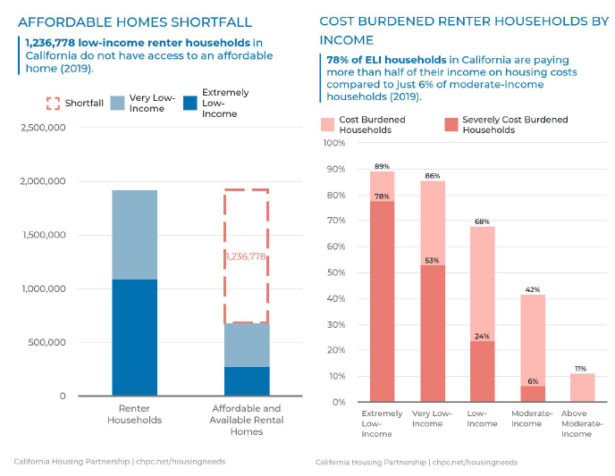

Figure 1. California is short 1.2 million units that are affordable to lower income earners.
Figure 2. Lower-income earners are more likely to be cost-burdened compared to 6% of moderate-income earners, meaning these households are more likely to experience housing insecurity or homelessness.

IV. Who is considered “low-income” in California?

Most subsidized affordable housing developments are built for families and individuals with incomes of 60% or less than AMI; as noted above, AMI is set regionally and means different things in different areas of the state. While these income limits may seem low, many “middle-class” and working families fall into low-income categories due to the high cost of housing. For example, a renter earning minimum wage (such as a pre-school teacher, janitor, or retail employee) needs to earn 2.8 times the state minimum wage to average asking rent in California. The average beginning elementary school teacher in California makes between $55,000 - $62,000 per year and a beginning high school teacher makes between $55,000 and $67,000 per year, which in some areas of the state falls into the low- or even very low-income categories.
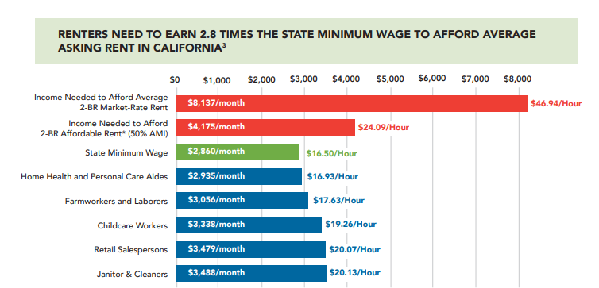

Figure 3. Working families in these fields – some of whom are considered “middle-class” - cannot afford to rent the average unit in California.

Sacramento County, 2025
 | LI (80% AMI) | VLI (50% AMI) | ELI (30% AMI)
2-person household | $82,350 | $51,450 | $30,900
4-person household | $102,900 | $64,300 | $38,600

Renters in Sacramento County need to earn $34.34 per hour - 2.1 times the state minimum wage - to afford the average monthly asking rent of $1,786.￼

Los Angeles County, 2025
 | LI (80% AMI) | VLI (50% AMI) | ELI (30% AMI)
2-person household | $96,950 | $60,600 | $36,400
4-person household | $121,150 | $75,750 | $45,450

Renters in Los Angeles County need to earn $49.58 per hour - 2.9 times the City of Los Angeles minimum wage - to afford the average monthly asking rent of $2,578￼.

Riverside County, 2025
 | LI (80% AMI) | VLI (50% AMI) | ELI (30% AMI)
2-person household | $71,600 | $44,750 | $26,850
4-person household | $89,500 | $55,950 | $33,500

Renters in Riverside County need to earn $38.33 per hour - 2.3 times the state minimum wage - to afford the average monthly asking rent of $1,993.￼

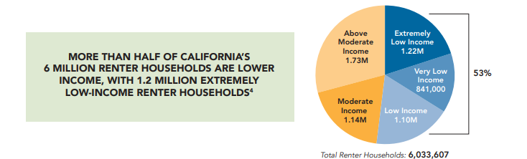

Figure 4. More than half of California’s renters are lower-income, thus likely rent-burdened and at risk of housing insecurity.

V. Developing affordable housing in California

Many of the costs to develop affordable housing are not fundamentally different than market-rate housing—the same land, construction, and regulation trends that increase costs in the market impact all housing development types. However, in many instances, affordable projects are subject to increased local scrutiny, which can further inflate costs. Further, unique funding mechanisms for affordable housing projects, like the Low-income Housing Tax Credit (LIHTC), may increase project timelines (and thus, costs) due to involving more stakeholders to ensure a project “pencils-out.”

A. How much does it cost to build an affordable unit in California?

Although many mistakenly presume the state must pay the entire cost to construct a new affordable housing unit, several different sources (including but not limited to federal and state tax credits, private activity bonds, private investment, and local funding) contribute to the cost. CHPC’s analysis of 15 years of data from HCD indicates that the average cost to the state’s main affordable housing program to produce 25,000 affordable rental units between 2002 and 2019 was about $70,000 per unit. In recent years, due to a number of factors, housing costs have increased. From 2021-2022, the aggregate state assistance increased to $128,000 per affordable unit.

Given that each new affordable home conservatively serves five households during the term of the state’s 55-year investment and assuming an average two-bedroom unit size and three-person occupancy, each $128,000 of state investment produces a housing unit that serves 15 low-income persons over the course of its 55 years affordability covenant. This works out to be a cost of about $154 per person per year.

B. What does it take to fund a housing project in California?

There are several key cost factors that can affect the ability of a housing project – affordable or market rate – to “pencil out.” Recently, all of these various factors have gone up in price, which, in turn, increases the price of housing. Some of the components to building housing include: land values, construction costs, materials and labor, development fees, permitting and development timelines, and regulatory requirements.

“Market rate” housing has relatively straightforward financing—a developer or property owner charges high enough rents so that there is sufficient cash flow left over after loan payments to attract an investor and provide cash for up-front costs to build. Rents in subsidized housing developments are intentionally more affordable (i.e., set at rents that are affordable to lower income families) than housing rented in the private market; therefore, cash flow is not sufficient for a typical investor. The high cost of land and construction, as well as regulatory barriers, in California generally makes it economically impossible to build new housing that can be sold or rented at prices affordable to such households. The private sector sometimes contributes affordable units or land donations mandatorily through inclusionary zoning policies or voluntarily through density bonus ordinances, described below. In most cases, however, some amount of public financial subsidy is needed from federal, state, and/or local governments in order to create affordable units.

Because housing is so expensive to build and the amount that a low-income household can reasonably afford to pay is relatively low, a significant amount of subsidy is needed for each affordable unit. In practice, this means that a developer must cobble together multiple sources – often more than six sources – to make the project pencil out.

In general, there are two main building blocks to fund an affordable rental housing development: 1) 9% tax credits and 2) 4% tax credits with Multifamily Housing Program (MHP) funds from HCD. In both cases, almost invariably a funding “gap” still exists that the developer must fill from other sources, usually those available from local governments.
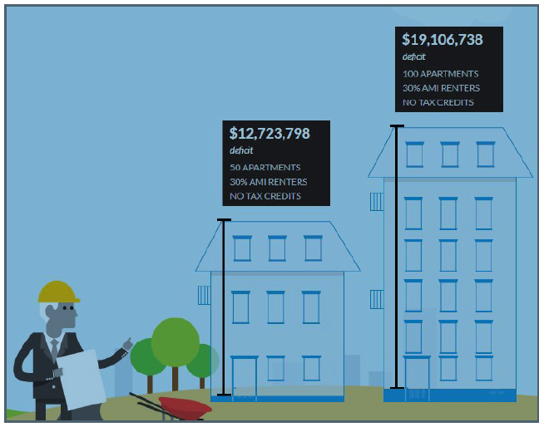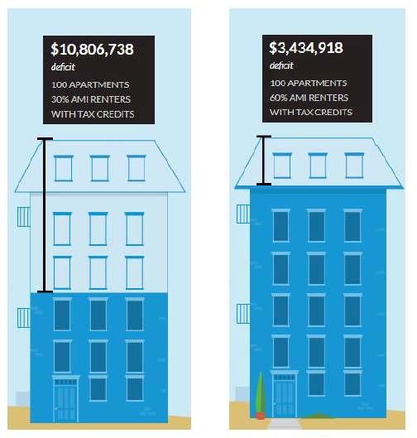

Figures 5 and 6. These two figures demonstrate the funding gap experienced by a developer attempting to make affordable housing project pencil-out with and without public subsidies in the form of low-income housing tax credits. Figure 5 shows A 50-unit project serving ELI households (i.e., 30% AMI) public subsidies in the form of tax credits will face a $12.7 million deficit, and a 100-unit project serving ELI households (i.e., 30% AMI) without public subsidies in the form of tax credits will face a $19.1 million deficit. By contrast, a 100-unit project serving ELI households (i.e., 30% AMI) with public subsidies (tax credits) will only face a $10.8 million deficit, and a 100-unit apartment serving LI households (i.e., 60% AMI) with public subsidies in the form of tax credits will only face a $3.4 million deficit.

Density bonus law allows developers and public entities to reduce or even eliminate the need to obtain subsidies for a particular “mixed-income” project (i.e., a project containing units affordable to a mix of incomes including units sold on the rental market at market rate rents) by allowing a developer that includes deed restricted units in their project to waive local development standards that reduce the overall cost of the project. Density bonus law also allows market rate developers to include more total units in a project than would otherwise be allowed by the local zoning in exchange for including affordable units in the project. Allowing more total units permits the developer to spread the cost of the affordable units more broadly over the market rate units. The idea of density bonus law is to cover at least some of the financing gap of affordable housing with regulatory incentives, rather than additional subsidy.

What is “social” housing?

Social housing is simply publicly-subsidized housing, but within a specific framework, most commonly used outside of the United States. All definitions of social housing distinguish it in various ways from privately-owned, for-profit housing provided through market mechanisms. The Assembly Select Committee on Social Housing held an informational hearing on October 20, 2021 and Rob Weiner from the California Coalition for Rural Housing shared the Organization for Economic Cooperation and Development (OECD) definition of social housing as: “the stock of residential rental accommodations provided at sub-market prices and allocated according to specific rules rather than according to market mechanisms.”

Under this definition, there are an estimated 480,000 subsidized housing units available for rent in California, or about 3.5% of the state’s housing stock. These deed-restricted affordable rental units are generally built using a mix of public and private financing and residency is restricted to low-income households that make no more than 80% of county area median income (AMI). Other versions of social housing specify permanent affordability requirements and ownership by the government or a non-profit entity. Most of California’s deed-restricted affordable housing is not publicly owned and the length of affordability requirements varies, though permanent affordability is not required in most cases.

Another variation of social housing involves making accommodations available to all individuals regardless of their household income. In particular, Vienna, Austria is often held up as an example of a large city with widespread mixed-income social housing. The Viennese model relies on two key components: government owned, funded, and maintained social housing blocks and public-private partnerships for mixed-income, cross-subsidized housing. Cross-subsidization occurs when higher income households pay market rate rents which then subsidize the below market rents for lower-income households. This mechanism is the same logic that underlies California’s density bonus law—a policy that allows residential developers to receive added density and other concessions and incentives from a local government in exchange for building a certain percentage of affordable units—and inclusionary housing ordinances—which mandate housing developers build a certain percentage of affordable units or pay in-lieu fees that are used to pay for future affordable housing.
Although Vienna provides access to affordable housing for a considerable portion of the population, private developers still play a role in the housing market. The large number of cross-subsidized mixed income housing units create competition in the private rental market, and private developers are forced to maintain low rents to remain competitive.

A. How is “Social Housing” defined in California?

In 2023, the Legislature passed and the Governor signed SB 555 (Wahab, Chapter 402, Statues of 2023). SB 555 (Wahab) directs HCD to conduct a study on social housing and develop recommendations to the Legislature for how it could be implemented in California. This study is currently in progress and includes a public engagement process to gather input from communities across the state. The final report and recommendations will be submitted to the Legislature by December 31, 2026.

SB 555 (Wahab) also established a definition of social housing in California statute, which includes all of the following: (1) Housing that is owned and managed by a public agency, cooperative, or non-profit for the benefit of its residents that are unable to afford market-rate housing. (2) A development with a mix of units affordable to families below 120% of the area median income; (3) Residents enjoy full protection against termination without just cause or other discriminatory, retaliatory, or other arbitrary reasons; (4) Land that remains permanently available for social housing purposes; and (5) Residents of the development have the right to participate in the decision-making and management of the housing development.

Social housing—which includes both the construction of new homes and the preservation of existing ones—is housing developed for public benefit rather than private profit. This approach is designed to support a broad range of Californians who are currently paying more than they can afford for housing. While market-rate units are excluded, there is a particular focus on serving the lowest-income tenants—those most burdened by rent—in proportions that reflect the state’s housing goals. All tenants are guaranteed due process before any eviction can proceed. Because rents are capped at no more than 30% of a tenant’s income, evictions for non-payment should be rare.

The study will analyze the funding sources available, constraints, social housing models, and any other subjects that HCD determines would help meet regional housing needs and aid in the creation of social housing in California. Additionally, the study must provide recommendations for how to utilize existing funding sources, reduce barriers and constraints, and make additional resources available to create social housing opportunities in California.

VII. STATE RESOURCES

A. Current housing agencies in state government

Currently, six state agencies – California Department of Housing and Community Development (HCD), California Housing Finance Agency (CalHFA), California Interagency Council on Homelessness (Cal-ICH), Tax Credit Allocation Committee (TCAC), California Debt Limit Allocation Committee (CDLAC), and the Strategic Growth Council (SGC) – administer most of the state’s programs that finance the development of affordable housing and homelessness policy.

Over the last several years, California has made significant investments in low- and moderate-income housing. This list contains the primary sources, which are described in more detail throughout this document.

- Low Income Housing Tax Credits (LIHTC), administered by the California Tax Credit Allocation Committee;
- Private Activity Bonds (PABs), administered by the California Debt Limit Allocation Committee;
- Greenhouse Gas Reduction Fund monies allocated to the Affordable Housing and Sustainable Communities Strategies Program (AHSC), administered by the Strategic Growth Council;
- Ongoing revenues generated through the Building Homes and Jobs Act (SB 2, Atkins, Chapter 364, Statutes of 2017), allocated through HCD and CalHFA;
- The Veterans and Affordable Housing Bond Act of 2018 (Proposition 1), allocated $3 billion in funds to affordable housing programs administered by HCD and CalHFA, and $1 billion to CalVet for homeownership opportunities.
- The No Place Like Home Program (established by Proposition 2, 2018), administered by HCD;
- One-time general fund investments in the budget to several affordable housing programs administered by HCD, including, but not limited to, the Multifamily Housing Program, Joe Serna Jr. Farmworker Housing Program, CalHome, and the Housing Accelerator Program.
- One-time general fund investments to the Homeless Emergency Aid Program (HEAP) and the Homeless Housing, Assistance, and Prevention Program (HHAP), administered by the Homeless Financing and Coordinating Council (HCFC);
- Behavioral Health Infrastructure Bond Act of 2024 (Proposition 1, 2024) authorized funds administered by HCD through the Homekey and VHHP programs.

It should be noted that of these investments, only funds from the Affordable Housing and Sustainable Communities program (AHSC), LIHTCs, and funds from SB 2 (Atkins, Chapter 364, Statutes of 2017), are ongoing sources of funding. Additionally, investments provided by Proposition 1 (2018) funds have been fully awarded. While the state has invested substantial amounts of one-time funding in recent years, advocates and local governments state that more predictable, significant, and permanent investments are necessary to address the substantial underproduction and ongoing needs for California’s lowest-income and working families.

California Department of Housing and Community Development (HCD)

HCD administers a variety of programs to meet a large range of housing needs, including emergency shelters, affordable rental housing, and affordable homeownership. As a general rule, HCD administers programs that receive money from the state’s General Fund, either directly through the budget or indirectly from general obligation bonds. In addition, HCD allocates certain federal funds, such as the HOME Program and the Community Development Block Grant (CDBG) Program, for smaller jurisdictions that do not receive these funds directly from the federal government. In 2018, voters approved Proposition 1, which dedicates $4 billion in general obligation bonds for housing, including $1 billion to the Cal-Vet Farm and Home Loan Program and $3 billion to housing programs for low- and moderate-income persons. In the same year, voters also approved Proposition 2, which dedicates $2 billion in bond proceeds to develop permanent supportive housing of persons who are in need of mental health services and are experiencing homelessness, chronic homelessness, or are at risk of chronic homelessness. In 2024, voters approved Proposition 1, which authorized about $1 billion each to the Homekey and Veterans Housing and Homelessness Prevention (VHHP) programs.

HCD’s major programs include:

- Project Homekey, which provides grants to counties, cities, and other government entities to purchase and rehabilitate housing including hotels, motels, vacant apartment buildings, and other types of innovative housing, and convert them into permanent, long-term housing for people experiencing or at risk of experiencing homelessness. The program received $550 million from federal Coronavirus Aid Relief Funds, with an additional $50 million from the general fund. The 2021-2022 budget included an additional $1.45 billion in grant funding for Homekey, which consists of $1.2 billion in federal funds under the American Rescue Plan of 2021 and $250 million in General Fund monies. Proposition 1 of 2024 allocated $922 million to this program.
- Housing Accelerator Fund, established in 2021, authorizes HCD, to award a forgivable loan or grant to a qualified rental housing development to replace federal and state low-income housing credit equity. This program received $1.75 billion from the 2021-2022 budget.
- The Multifamily Housing Program (MHP), which finances affordable rental housing. This program received $1.5 billion from Proposition 1 bond funds.
- Homeless Housing, Assistance, and Prevention Program (HHAPP). In 2019, the budget created the HHAPP and invested $650 million in one-time funds to build upon HEAP by funding rapid rehousing, permanent supportive housing, job programs, shelter and navigation construction, upon a demonstration of demonstrated need, and innovative projects. An additional $300 was allocated to HHAPP in the 2020-2021 budget. In 2021, a total of $2 billion was allocated to HHAPP: $1 billion for Round 3 in the 2021-22 fiscal year, and an another $1 billion for Round 4 in the 2022-23. Another $1 billion was allocated in the 2023-24 and 2024-25 fiscal years.
- The Infill Infrastructure Grant Program, which funds capital improvement projects to develop housing projects in infill areas. This program received $300 million from Proposition 1 bond funds, $500 million from the 2019-2020 budget, and $534 million from the 2021-22 budget.
- The Local Government Planning Supports Grants Program, established by the 2019-2020 budget, which provides grants to local governments to support planning that increases and accelerates housing production.
- Regional Early Action Plan Grant (REAP) Program of 2021, provides regions with funding for transformative planning and implementation activities, meaning housing, planning, infrastructure investments supporting infill housing, and other actions that enable meeting housing goals that also result in per capita vehicle miles traveled reductions. This program received $600 million.
- The Joe Serna Jr. Farmworker Housing Grant Program, which funds housing for farmworker families. This program received $300 million from Proposition 1 bond funds.
- The CalHome Program, which funds activities to help low-income families become or remain homeowners. This program received $300 million from Proposition 1 bond funds.
- California Emergency Solutions and Housing (CESH), provides grant funds to assist persons experiencing or at-risk of homelessness. This program receives funds from the Building Homes and Jobs Act Trust Fund (SB 2, Chapter 364, Statutes of 2017).
- No Place Like Home, authorized through Proposition 2, 2018, dedicates up to $2 billion in bond proceeds to invest in the development of permanent supportive housing for persons who are in need of mental health services and are experiencing homelessness, chronic homelessness, or who are at risk of chronic homelessness.

For a more complete listing of HCD’s currently funded programs, see http://hcd.ca.gov/grants-funding/active-funding/index.shtml

California Housing Finance Agency (CalHFA)

CalHFA is the state’s affordable housing bank. CalHFA borrows money from the private financial market at below-market interest rates by issuing tax-exempt revenue bonds. CalHFA passes these interest rate savings on to low- and moderate-income first-time homebuyers and affordable rental housing developers by offering below market-rate mortgages. These bonds are backed only by CalHFA revenues and not by the state General Fund. CalHFA also provides downpayment assistance in the form of deferred, “silent second” mortgages (i.e., the borrower makes no monthly payments but repays the loan at sale or refinance) for families who need extra assistance achieving homeownership. CalHFA received $150 million for home purchase assistance from Proposition 1 (2018) bond funds to provide first and junior loan options for low- to moderate-income families, including low to zero interest rate down payment assistance loans.

On behalf of counties that choose to dedicate some of their revenues from Proposition 63 — the 1% additional income tax on upper-income earners for mental health services — for supportive housing, CalHFA also administers the MHSA Program in coordination with the Department of Mental Health. This program provides developers of affordable housing who agree to set aside units for persons with mental illness with both capital funding and critical operating and service funding, which are needed to provide essential services and compensate for the little amount of rent that these residents are able to pay.

CalHFA receives 15% of the funds generated by SB 2 (Atkins, Chapter 364, Statutes of 2017) for the Mixed Income Program (MIP) for the purposes of creating mixed-income, multifamily residential housing for lower- or moderate-income households. The 2019-2020 Budget provided an additional one-time $500 million investment into the MIP program. CalHFA also received $150 million for Home Purchase Assistance from Proposition 1 bond funds to provide first and junior loan options for low- to moderate-income families, including low to zero interest rate down payment assistance loans.

In September 2021, CalHFA launched a new program to help homeowners finance ADUs. The ADU Grant Program will provide qualified homeowners up to $25,000 to help cover construction costs, with a focus on homeowners with low incomes, low equity in their homes, and those residing in low-income areas.

The 2022-23 and 2025-26 budget provided $500 million for CalHFA to create and administer the California Dream for All homebuyer aid program. This program will provide shared appreciation loans to qualified low- and moderate-income, first-time homebuyers.

For more information about CalHFA and its programs, see http://www.calhfa.ca.gov/.

California Tax Credit Allocation Committee (CTCAC)

Both state and federal laws allow for tax credits to be awarded each year to the developers of affordable rental housing. CTCAC within the State Treasurer’s Office allocates these tax credits to individual developments. Because the developers who receive credits generally have little or no tax liability of their own, they invite corporations to buy in to their projects in order to take advantage of the tax credits. The federal government provides two types of tax credits, known as 9% and 4% credits. CTCAC allocates a defined amount of 9% credits through a highly competitive system, and these equity investments can cover most of a project’s total development cost. Four percent credits come automatically with an allocation of tax-exempt bond financing from the Debt Limit Allocation Committee (CDLAC). These 4% credits are less valuable, but the overall supply is significantly higher. The 2019-2020 budget expanded the state tax credits by $500 million for the following budget years: 2019-2020, 2020-2021, 2021-2022, and 2022-23.

For more information, please see http://www.treasurer.ca.gov/ctcac/.

Debt Limit Allocation Committee (CDLAC)

Federal law also allows state and local governments to issue a defined amount of tax-exempt “private activity” bonds each year in order to facilitate private development, including the development of affordable housing. CDLAC within the State Treasurer’s Office allocates this private activity bond authority in California. The primary beneficiary is affordable rental housing. Tax-exempt bonds lower the interest rate that developers pay on their mortgages. Projects that receive tax-exempt bond funds also automatically receive federal 4% low-income housing tax credits.

For more information, please see http://www.treasurer.ca.gov/cdlac/.

Strategic Growth Council (SGC)

In 2014, the Legislature committed ongoing funding derived from the California Air Resources Board’s Cap-and-Trade Program to the SGC to administer the Affordable Housing and Sustainable Communities Program. This program funds land use, housing, transportation, and land preservation projects to support infill and compact development that reduces greenhouse gas emissions. At least half of the funds must support affordable housing projects. Generally, due to significant revenue uncertainty, SGC cannot always predict the amount of for the next round of applications from the Greenhouse Gas Reduction Fund (GGRF).

SB 840 (Limon, et al., Chapter 121, Statutes of 2025) reconfigures the continuous appropriations established for GGRF and sets new legislative intent for how GGRF monies are spent. The bill also directs the California Air Resources Board (CARB) to assess and update compliance offset protocols, and establishes a new unit within the Legislative Counsel Bureau to support climate and environmental policymaking efforts. GGRF monies first must be used to backfill revenue generated by the State Responsibility Area fire prevention fee and to establish the new Bureau. If there is additional money remaining, $1 billion shall be granted to High-Speed Rail and $1 billion to other specified purposes. If after that there is additional money remaining, the Affordable Housing and Sustainable Communities program shall be granted monies proportional to past GGRF continuous appropriations.

For more information, please see http://www.sgc.ca.gov/.

Interagency Council on Homelessness (Cal-ICH)

Cal-ICH, housed within the state Business, Consumer Services, and Housing (BCSH) Agency, was created in 2017 to oversee the implementation of “Housing First” policies, guidelines, and regulations to reduce the prevalence and duration of homelessness in California. Housing First is an approach to quickly and successfully connect individuals and families experiencing homelessness to permanent housing without preconditions and barriers to entry, such as sobriety, treatment, or service participation requirements. Cal-ICH’s mission is to develop policies, identify resources, benefits, and services to prevent and work toward ending homelessness in California. By July 1, 2019, agencies and departments administering State programs in existence prior to July 1, 2017, were required to collaborate with the Cal-ICH to revise or adopt guidelines and regulations that incorporate the core components of Housing First.

Between 2018 and 2024, Cal-ICH implemented two key homelessness funding programs: HEAP and HHAPP. In 2024, HHAPP implementation was transitioned over to HCD.

For more information, please see https://bcsh.ca.gov/calich/grants.html.

Governor’s Reorganization Plan (GRP) 1 of 2025

The GRP 1 of 2025 established a stand-alone housing and homelessness agency within the administration consistent with the chart below. It should be noted that several existing housing and homelessness programs administered by other agencies (e.g., those administered by the Department of Health Care Services or Department of Social Services) were not proposed to be moved over to the new agency. Additionally, CDLAC and TCAC will remain at the Treasurer’s Office and are unaffected by this reorganization.

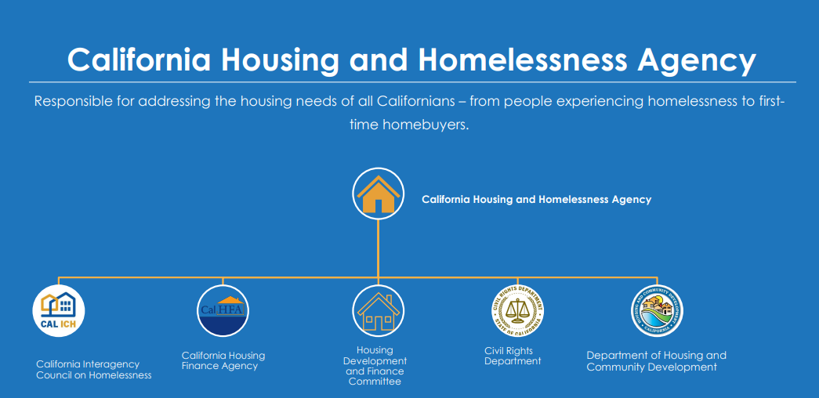

Figure 7. This chart shows the organizational structure of the newly created California Housing and Homelessness Agency. The current Business Consumer Services and Housing Agency (BCSCH) will be broken-up into two new agencies: the California Housing and Homelessness Agency and the Business and Consumer Services Agency. CDLAC and TCAC will remain at the Treasurer’s Office and are unaffected by this reorganization.

B. Demand far exceeds available state funds

When HCD announced the most recent Notice of Funding Availability(NOFA), it received more than $3.5 billion in funding requests for $825.5 million available – meaning there was an oversubscription of 4:1. Of these funds, $380 million was awarded through the Multifamily Housing Program; more than $2.8 billion (or 15,816 units) in funding requests were received for this program alone – an oversubscription of 10:1. With these funds, affordable housing providers could have produced an additional 13,888 shovel ready units. Below is a chart showing the demand for state tax credits from 2020-24.

Figure 8: This chart shows the demand for state credits from 2020-2024. The yellow bars indicate what developers applied for while the navy blue bars indicate how much was available.
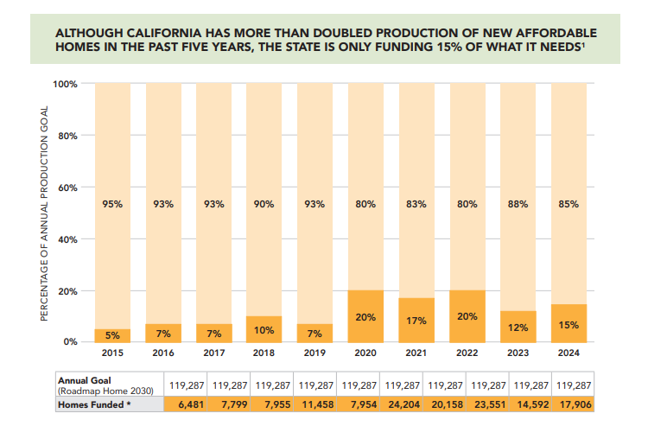
Figure 9. While California has been investing more for affordable housing construction in recent years, much more money is needed to keep up with demand and to backfill the reduction in funding funds starting in the early 1980’s.

VIII. FEDERAL RESOURCES

California receives annual funding from three major federal housing programs administered by the U.S. Department of Housing and Urban Development (HUD): HOME Investment Partnerships Program (HOME), Emergency Solutions Grants (ESG) Program, and Community Development Block Grant (CDBG) Program. Larger urban areas, called entitlement jurisdictions, receive funding directly from the federal government. Smaller, more rural areas, known as non-entitlement jurisdictions, are awarded funds through the state (i.e., HCD).

- HOME Program - provides formula grants to states and localities, often in partnership with local nonprofit groups, to fund a wide range of activities including building, buying, and/or rehabilitating affordable housing for rent or homeownership or providing direct rental assistance to low-income people. HOME is the largest federal block grant to state and local governments designed exclusively to create affordable housing for low-income households. In 2019, California entitlement jurisdictions received $130.6 million and HCD received $43.4 million for non-entitlement jurisdictions.

- ESG (Emergency Solutions Grants) Program - provides funding to: (1) engage homeless individuals and families living on the street; (2) improve the number and quality of emergency shelters for homeless individuals and families; (3) help operate these shelters; (4) provide essential services to shelter residents, (5) rapidly re-house homeless individuals and families, and (6) prevent families/individuals from becoming homeless. In 2019, California entitlement jurisdictions received $21.2 million and HCD received $12.2 million for non-entitlement jurisdictions.

- CDBG (Community Development Block Grant) Program - a flexible program that provides communities with resources to address a wide range of unique community development needs, including affordable housing. In 2019, California entitlement jurisdictions received $359.2 million and HCD received $32 million for non-entitlement jurisdictions. Community Development Block Grant Disaster Recovery (CDBG-DR) grants may be awarded to state and local governments when the president declares a major disaster for expenses related to “disaster relief, long-term recovery, restoration of infrastructure and housing, and economic revitalization.”

- National Housing Trust Fund (NHTF) - a newer affordable housing production program that complements existing Federal, state, and local efforts to increase and preserve the supply of decent, safe, and sanitary affordable housing for extremely low- and very low-income households, including homeless families. NHTF funds may be used for the production or preservation of affordable housing through the acquisition, new construction, reconstruction, and/or rehabilitation of non-luxury housing with suitable amenities. In 2019, California received $3.7 million.

Fair Market Rents (FMRs) are used to determine payment amounts and rent ceilings under several programs administered by the US Department of Housing and Urban Development (HUD). HUD estimates FMRs each year for metropolitan areas and non-metropolitan counties across the country. Metropolitan areas often cover a large geographic region; for example, the Sacramento metropolitan area includes El Dorado, Placer, Sacramento, and Yolo Counties. The FMR includes the total cost of shelter plus utilities (all major utilities except telephone, cable or satellite television, and Internet services). FMRs go into effect at the beginning of each federal fiscal year (October 1).

It is important to note that the FMR is a calculation of the rent level at the 40th percentile, meaning that 60% of the area’s rents fall above that level. In comparison, “market rent” refers to the amount a property can be expected to rent for on the open market, in line with other similar properties in the area. For more information on how FMRs are calculated and used, please see https://www.huduser.gov/portal/datasets/fmr.html.

The National Low Income Housing Coalition publishes an annual “Out of Reach” report that documents the gap between renters’ wages and the cost of rental housing (based on FMRs) across the US. Specifically, the report calculates a “housing wage,” an estimate of the hourly wage a full-time worker must earn in order to afford a rental home at the FMR without spending more than 30% of his or her income on housing costs (the accepted standard for affordability). According to the 2023 report, the housing wage for California is $42.25 for a two-bedroom FMR and $33.97 for a one-bedroom FMR. A worker earning the state minimum wage of $15.50 per hour would have to work 109 hours per week (nearly three full-time jobs) to afford a two-bedroom FMR or 88 hours per week (more than two full-time jobs) to afford a one-bedroom FMR. In comparison, the 2021 national housing wage is $28.58 per hour for a two-bedroom rental and $23.67 per hour for a one-bedroom rental.

IX. LOCAL RESOURCES

In addition to these state programs, local governments may have additional resources to support affordable housing. As noted above, some localities receive funds directly from the federal government. Much less common are local housing trust funds that receive dedicated fee revenues, such as commercial development linkage fees, a portion of transient occupancy taxes, or other sources. Cities and counties that used to have redevelopment agencies may also have limited income from the payback of old loans that remains available for affordable housing purposes. Several jurisdictions in recent elections have passed voter-approved initiatives to expend bonds or impose fees or taxes to raise money for affordable housing construction.

In addition to providing public funds, more than 100 cities and counties have adopted inclusionary housing ordinances, requiring developers of market-rate housing to build, dedicate land for, or pay in-lieu fees to support the development of affordable housing. State law also requires local governments to provide “density bonuses” of up to 35% to projects that include specified percentages of affordable housing. With a density bonus, a developer is able to build more units than the zoning otherwise allows, which allows the developer to use the additional revenue to offset the cost of providing the affordable units.

Due to the loss of redevelopment funds in 2012, the legislature approved and the governor signed two main pieces of legislation to permit local jurisdictions to fund affordable housing through tax increment financing (TIF). The first bill, SB 628 (Beall, Chapter 785, Statutes of 2014), allows a city or county to create an Enhanced Infrastructure Financing District (EIFD) to finance specified facilities and infrastructure projects, including housing for low- and moderate-income households using tax increment revenue. The second bill, AB 2 (Alejo, Chapter 319, Statutes of 2015) authorizes local governments to create Community Revitalization and Investment Authorities (Authority) to use tax increment revenue to improve the infrastructure, assist businesses, and support affordable housing in disadvantaged communities. AB 2 also requires that not less than 25% of all taxes that are allocated to the Authority be deposited into a separate Housing Fund and used for the purposes of increasing, improving, and preserving the community’s supply of low- and moderate-income housing available at an affordable cost. Several subsequent bills have been enacted to fund specific purposes within CRIA and EIFDs. To date, however, only 15 EIFDs have been created.

In addition to EIFDs and the Authorities created by SB 2, the Legislature has created five other TIFs specific to the development of housing, including facilitating the conversion of commercial properties into housing (adaptive reuse). The committee is unaware of the creation of any of these districts, largely because all RDA 2.0 tools do not authorize the participation of school districts, which substantially reduces the amount of money that is generated.

In 2024, the Governor signed SB 440 (Skinner, Chapter 767, Statutes of 2024), which authorizes two or
more local governments to establish a regional housing finance authority to raise, administer, and allocate funding for affordable housing and provide technical assistance at a regional level for affordable housing development. This legislation was modeled upon recent efforts by the Bay Area and Los Angeles County to establish similar regional housing authorities designed to finance new and preserve existing affordable housing, as well as provide tenant protections on a regional level.

Low-income households are those whose members earn less than 80% of the area median income (AMI). Very low-income households are those whose members earn less than 50% AMI. State and federal standards deem housing affordable when households spend no more than 30% of their income on housing.
California Housing Partnership Corporation. California Housing Needs Dashboard. Accessible here: https://chpc.net/housingneeds/
The term “lower income” is used to mean all low-income categories, 0% to 80% of AMI.
California Housing Partnership Corporation. Housing Needs Dashboard. Accessible here: https://chpc.net/housingneeds/?view=37.405074,-119.26758,5&county=California&group=housingneed&chartgroup=cost-burden-parent|current&chart=shortfall|current,cost-burden-all|current,cost-burden-oa|current,cost-burden-yc|current,cost-burden-re|current,cost-burden-re-inc,homelessness,overcrowding,overcrowding-ten,tenure-re,historical-rents,vacancy,asking-rents|2024,budgets|2025,funding|current,state-funding,multifamily-production,lihtc|2010:2024:historical,rhna-progress|5
California Housing Partnership Corporation. California Housing Needs Report 2025. Accessible here: https://chpc.net/wp-content/uploads/2025/03/CHP_State-Housing-Needs-Report-2025.pdf
Statewide Average Salaries and Expenditure Percentages: 2023-24. California Department of Education. Accessible here: Average Salaries & Expenditure Percentage - CalEdFacts (CA Dept of Education)
California Housing Partnership Corporation. California Housing Needs Report 2025. Accessible here: https://chpc.net/wp-content/uploads/2025/03/CHP_State-Housing-Needs-Report-2025.pdf
Sacramento County 2025: Affordable Housing Needs Report. California Housing Partnership Corporation. Accessed here: Sacramento_Housing_Report-2.pdf
California Housing Partnership Corporation. California Housing Needs Report 2025. Accessible here: https://chpc.net/wp-content/uploads/2025/03/CHP_State-Housing-Needs-Report-2025.pdf
The Cost of Building Housing. Terner Center for Housing Innovation. Accessible here: https://ternercenter.berkeley.edu/wp-content/uploads/2020/08/Cost_of_Building_Housing_Series_Framing.pdf
Kneebone, Elizabeth and Reid, Carolina. The Complexity of Financing Low-Income Housing Tax Credit Housing in the United States. Terner Center for Housing Innovation, UC Berkeley. Accessible here: LIHTC-Complexity-Final.pdf
California Assembly Select Committee on Social Housing. October 20, 2021. https://www.assembly.ca.gov/media/assembly-select-committee-social-housing-20211020/video
In January 2025, the Governor proposed to reorganize the Business Consumer Services and Housing Agency, which oversees several state housing departments. The Legislature did not take action on this proposal, which means it took effect in July, 2025. More details of this reorganization plan can be found below.
Moderate-income households are those members earning 80-120% AMI.
Until 2025, AHSC received 20% of the monies in the GGRF. SB 840 (Limon et. al, Chapter 121, Statutes of 2025) changed the GGRF allocations as follows: GGRF monies first must be used to backfill revenue generated by the State Responsibility Area fire prevention fee and to establish a new Bureau. If there is additional money remaining, $1 billion shall be granted to High Speed Rail and $1 billion to other specified purposes. If after that there is additional money remaining, the AHSC program shall be granted monies proportional to past GGRF continuous appropriations.
By statute, the state pays annually $70 million to the state LIHTC program, adjusted for inflation, which is generally about $100 million per year.
Proposition 63 imposes a 1% income tax on personal income in excess of $1 million. Much of the funding has been provided to county mental health programs to fund programs consistent with their local plans.
HEAP immediately predates HHAPP, and was established through the budget to provide localities with flexible block grant funds to address their immediate homelessness challenges. The 2018-2019 budget allocated $500 million in one-time funding to enable local governments to respond to homelessness.
California Housing Partnership Corporation. California Housing Needs Report 2025. Accessible here: https://chpc.net/wp-content/uploads/2025/03/CHP_State-Housing-Needs-Report-2025.pdf
Entitlement jurisdictions are cities and counties with more than 50,000 residents.
HCV Program, project-based Section 8 contracts, Moderate Rehabilitation Single Room Occupancy Program, Home Investment Partnerships Program, Emergency Solution Grants Program, Continuum of Care, and Public Housing units.

